Draft
ATLAS COOLING OF THE DETECTOR
TEST IN MAGNETIC fIELD
Objectives
To validate material in UX cavern

Abstract
Test of an electrical centrifugal pump in a magnetic field.

Prepared |  |  |  | Verified |  |  | Approved
By: | BONNEAU Pierre |  |  | By: | Reviewer |  | By: | Approver
Date: | 2002/03/22 |  |  | Date: | 200Y/MM/DD |  | Date: | 200Y/MM/DD
Distribution
List
History of Changes
Rev. No. |  | Date | Pages |  |  | Description of Changes

Table of contents
1. Description 3
2. Results 4
3. conclusion 6

Description
We have tested a magnetic drive centrifugal pump in a magnetic field. The pump is an IWAKI MD30RZ with a typical 8 [l/mn] at head of 6.7 [m] (Figure 1).

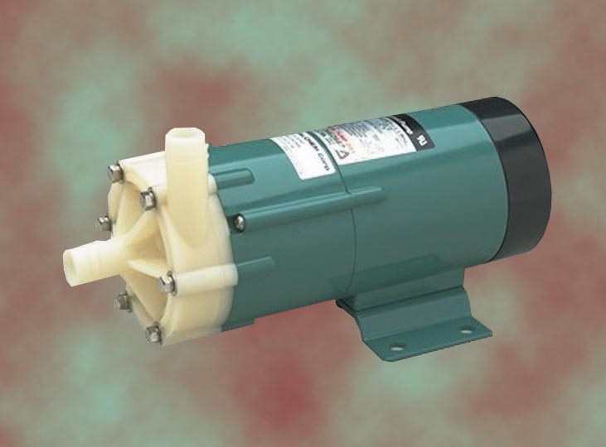

Figure 1 - IWAKI MD30RZ

The pump is connected to an open tank and flows through a flowmeter and a manometer. A hand valve allows adjusting the flow in the circuit (Figure 2).
We install the pump inside the magnet MNP17 in the building 168 – Thanks to R. Rey-Mermier of EP-TA3. This magnet allows field from 0 to 1000 [Gauss].

Figure 2 – Layout of the test

Results
First results show a small decrease of the performances at 500 [Gauss] while no significant effect at 250 [Gauss] (Figure 3). We saw also that the pump stops at around 700 [Gauss]. But we didn’t know if it was because of the magnetic drive slipping or because of the electrical motor falling.
At 500 [Gauss] we noticed that the pump was overheating, causing short failure.

Figure 3 – Performance of the MD30RZ

We added an ampere meter on the supply line of the pump and the results are more significant (Figure 4).
On the pressure curve we can see the first effect of the magnetic field at around 250 [Gauss], while, on the current curve, the effect starts at 100 [Gauss].
At 400 [Gauss] the current in the motor is already twice the nominal current. We clearly couldn’t work with superior magnetic field and would have to cool down the motor if working in these conditions.
The stop of the pump at 750 [Gauss] is caused by the motor.

We repeat the test in the same condition with a shielding tube around the pump (Figure 5) and we can see on the graph that we don’t have significative effect before 300 [Gauss].
The shielding is made of a simple 3.6mm thickness black steel – Acier ST37.0, scem 39.18.05.108.5.

Figure 4 – Performance of the MD30RZ in a magnetic field

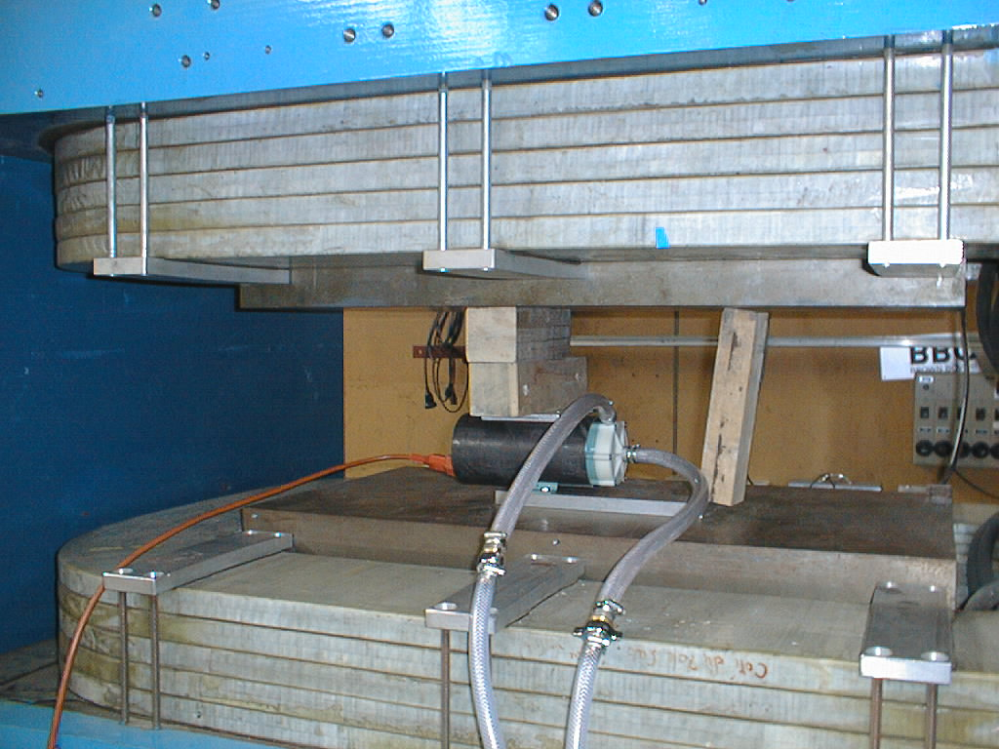
Figure 5 – The MD30RZ with its shielding inside the magnet

conclusion
The circulators of the cooling systems for the electronics in the detectors will be located on the floor of UX15 where a magnetic field of 300 [Gauss] is expected.
From this test we see that a simple low cost shielding can protect the electrical motor of these circulators to keep their performance at their initial level.

