 | Work Package Document for ATLAS Cooling Systems Construction, Installation and Commissioning
ATLAS Project Document No: | EDMS Document No: | Created: 21/10/2001 | Page: 1 of 7
ATC-GE-MA-0008 | 360259 | Modified:24/01/2003 | Rev. No.: 1.0

Work Package Document for ATLAS Cooling Systems Construction,
Installation and Commissioning

Abstract
This document describes the technical work, cost and manpower needs to realize the ATLAS detector cooling systems. It proposes a collaboration between ATLAS and ST/CV for the construction and commissioning of these cooling systems. A schedule is also included.
Prepared by:  P. Bonneau ST/CV  J. Godlewski EP/ATI | Checked by:  M. Bosteels ST/CV  R. Eisenstein EP/HC  M. Hatch EP/ATI  M. Wilhelmsson ST/CV |  | Approved by:  M. Nessi EP/ATO
Distribution List:  J. Inigo-Golfin ST/DI  R. Leitner EP/HC  G. Mikenberg EP/ATM  H. Oberlack EP/ATA  M.A. Pimenta Dos Santos ST/CV  S. Stapnes EP/ATT  G. Tappern EP/ATI |  | EDMS approval required by:  M. Bosteels ST/CV  J. Inigo-Golfin ST/DI  M. Nessi EP/ATO  M. Nordberg EP/ATO  A. Scaramelli ST  D. Schlatter EP  V. Vuillemin EP/DI  M. Wilhelmsson ST/CV

Table of Contents

1 Introduction 3
2 The Cooling Systems and Their Associated Work Units 3
2.1 WU1: Evaporative system for the Pixel and the SCT detectors and their thermal screens. 3
2.1.1 Work Unit description 3
2.1.2 Deliverables from ST/CV 3
2.2 WU2: Mono-phase pressurised systems with C6F14 as cooling liquid 4
2.2.1 Work Unit description 4
2.2.2 Deliverables from ST/CV 4
2.3 WU3: Mono-phase leakless systems with water as a cooling liquid 4
2.3.1 Work Unit description 4
2.3.2 Deliverables from ST/CV 4
2.4 WU4: Pressurised systems with water as cooling liquid 5
2.4.1 Work Unit description 5
2.4.2 Deliverables from ST/CV 5
3 Control System 5
3.1 Introduction 5
3.2 Primary and Secondary Cooling Circuit Control System 6
3.2.1 Primary cooling circuit Control system 6
3.2.2 Secondary cooling circuit Control system 6
3.3 Work Package 6
3.3.1 Process control Design 6
3.3.2 Process control installation and commissioning 7
4 Organization 7
5 Schedule 7
6 Available Manpower Resources 8
7 Cost Estimate 8
8 References 9

Introduction
This document gives the summary of requirements for the design, manufacturing, and installation and commissioning of the ATLAS detector cooling systems. The expected help from ST/CV is described with as many details as available at this stage of the project. The package is divided into work units relative to each system. Description of the individual cooling systems and their preliminary specifications can be found at ATLAS Cooling Systems ATC-TL-EN-0001 [1].

In the present document we use the following definitions:
- “Cooling unit” is a mechanical assembly consisting of a pump, heat exchanger, reservoir and adjacent valves and manifolds.
- “Cooling control system” is an assembly consisting of a control rack with PLCs, various interfaces for monitoring action and necessary connections with cooling system elements.
- “Cooling system” is an assembly consisting of a cooling unit, a cooling control system, and primary and secondary piping connected functionally to the Detector Control System.

The Cooling Systems and Their Associated Work Units
For all of the Work Units described below ATLAS is asking ST/CV to make a cost estimate before the end of March 2003.

All the drawings listed in the Work Unit descriptions are available at the ATLAS Technical Coordination Cooling Systems web page http://atlas.web.cern.ch/Atlas/TCOORD/Activities/Installation/Fluid/cooling.html

WU1: Evaporative system for the Pixel and the SCT detectors and their thermal screens.

Work Unit description
This system will use C3F8 as a cooling liquid. Three compressor units with total cooling capacity of around 80 kW will be placed in USA15 and will be connected via the services gallery to the distribution racks situated on the platforms of HS structures. A short description of the evaporative system, its layout, piping and heat capacity is given in the document ATC-TL-EN-0006 [2].

Deliverables from ST/CV
ATLAS expects from ST/CV the following deliverables:
- The cooling unit design, construction, installation, and commissioning
- The control system design, manufacturing (hardware and software), manufacturing, installation, and commissioning. See paragraph 3.
- Connections to USA15/UX15: electrical lines, pneumatic lines and pipes
- Piping from the distribution racks, manifolds to the detector heat exchangers
- Connection to the primary circuits
- Cooling system commissioning
- Maintenance and operation.

WU2: Mono-phase pressurised systems with C6F14 as cooling liquid

Work Unit description
In this Work Unit two identical cooling units with cooling capacity of 70 kW will be built:
WU2-1: TRT cooling system: 1 unit, 70 kW
WU2-2: Cable cooling system: 1 unit, 70 kW.
For the TRT cooling system drawings are accessible at ATC-TL-ED-0001.

Deliverables from ST/CV
ATLAS expects from ST/CV the following deliverables:
- The cooling unit design, construction, installation and commissioning
- The control system design, manufacturing (hardware and software), manufacturing, installation and commissioning. See paragraph 3.
- Connections to USA15/UX15: electrical lines, pneumatic lines and pipes.
- Connection to the primary circuits
- Piping from the distribution racks, manifolds to the detector heat exchangers¹
- Cooling system commissioning
- Maintenance and operation.

WU3: Mono-phase leakless systems with water as a cooling liquid

Work Unit description
There are four cooling systems within this Work Package:
- WU3-1: Liquid Argon cooling system - 1 unit, 255 kW
Information concerning the cooling unit, its placement inside the UX15 cavern and the proposed piping layout is available in the EDMS document ATC-TL-ED-0002.
- WU3-2: Tile calorimeter cooling system – 1 unit, 60 kW
Information concerning the cooling unit, its placement inside the UX15 cavern and proposed piping layout is available in the EDMS document ATC-TL-ED-0003.
- WU3-3: Muon and trigger electronics mono-phase cooling system – 1 unit, 90 kW
The specification for this system is not finalized. Available information can be found in the proposal for Muon Cooling System Parameters, ATC-TL-EN-0007.
- WU3-4: Magnet and LAr diffusion vacuum pumps monophase cooling system- 1 unit, 65 kW
The preliminary specification for this system is made and waiting for the final confirmation by Magnet and Liquid Argon subsystems. Relevant drawings are at ATC-TL-ED-0004.

Deliverables from ST/CV
ATLAS expects from ST/CV the following deliverables:
- The cooling unit design, construction, installation and commissioning
- The control system design, manufacturing (hardware and software), manufacturing, installation and commissioning. See paragraph 3.
- Connections to USA15/UX15: approx. 150 m with electrical lines, pneumatic lines and pipes.
- Connections to the primary circuits
- Piping from the distribution racks, manifolds to the detector heat exchangers¹
- Cooling systems commissioning
- Maintenance and operation.

WU4: Pressurised systems with water as cooling liquid

Work Unit description
WU4-1: Racks cooling system in US15 – 1 unit, cooling capacity is not final as yet. A first estimation is about
150 kW.

Deliverables from ST/CV
- The cooling unit design, construction or purchasing, installation, commissioning
- The control system design, manufacturing (hardware and software), manufacturing, installation, commissioning. See paragraph 3.
- Connection to the primary circuits on the surface
- Piping to the racks and connection to the racks heat exchangers
- Cooling systems commissioning
- Maintenance and operation.

Control System

Introduction

The control system is based on a standard components and well-proven model architecture composed of the following elements:

- The ST/CV PLCS
- The ST/CV local SCADA supervisor
- The Experiment Supervisor for ECR monitoring
- The TDS server for the TCR integration

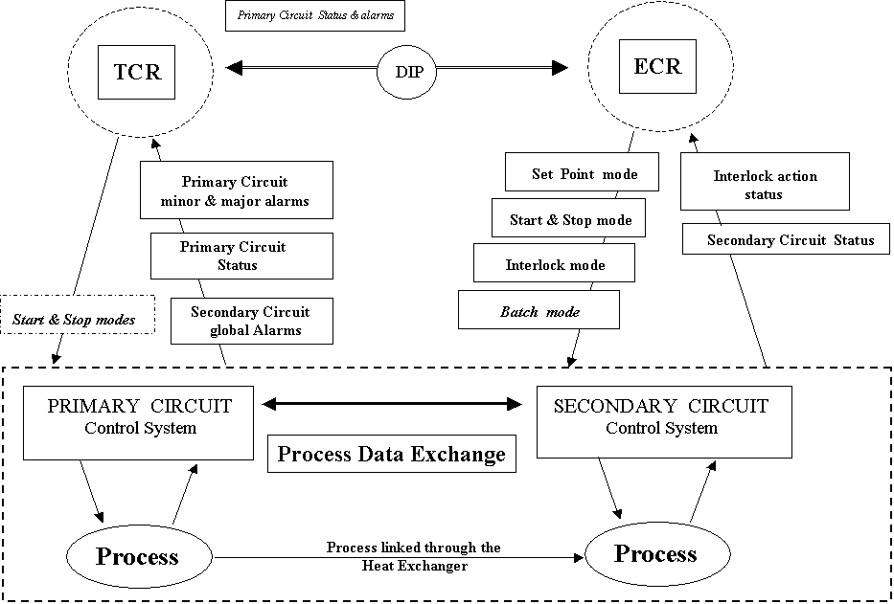

The cooling systems will have their own control systems based on CERN recommended PLCs, which should work even if the supervisor is not working. The process control layer is handled entirely in the PLC, which can work in a stand-alone mode. The cooling control system is independent of the supervisor being used. ST/CV has its own choice of local supervisor for its purposes.

The role of the TCR (Technical Control Room) regarding cooling and ventilation is assumed to be to receive alarms and to call the appropriate service to intervene when required. No actions are at this moment expected to be taken from the TCR.

Primary and Secondary Cooling Circuit Control System

Primary cooling circuit Control system

ST/CV are responsible for all aspects of the installation, control and maintenance of the control system for the primary control circuits and chilled water production. Information on the primary cooling circuits will be made available to the ECR (Experiment Control Room). This information will be exchanged via DIP ( Data Interchange Protocol). The primary cooling circuit will be monitored from the ST/CV local SCADA system (Wizcon)

Secondary cooling circuit Control system

ST/CV is responsible for design and implementation of the process control layer including the closed-loop feedback. The design is based on the requirement from the experiment or sub-detector. ST/CV has the overall responsibility for the control systems and the implementation of the appropriate control loops. The experiment is responsible for the operation of the secondary cooling circuit. The experiment will be able selectively to switch on/off individual cooling circuits as well as to modify the temperature operating set-point. The secondary cooling circuit will be monitored from the ST/CV local SCADA system (Wizcon). No action should be triggered from the ST/CV SCADA whilst the circuit is in operation by the experiment.

Information is required to be exchanged between the primary and secondary circuit control systems. This is done at the level of their respective PLCs in order for predictive actions to be performed.

Work Package

The typical work package for designing the process control system consists of the following:

Process control Design

- Definition of the process equipments for measurements and final elements (typical sensors, control valve..)
- Process operability
- Definition of the control structure
- Definition and analysis of the control for safety principles (alarms, safety interlock system safety valves or action)
- Definition of the control algorithms (design of appropriate feedback loop and controller algorithm for dynamic performance)
- Stability Analysis and controller tuning
- Simulation of the control system transient response
- Performance monitoring

Process control installation and commissioning

- Installation and test of Process equipment
- Test of control structure element
- Monitoring performance tests
- Dynamic tests and optimization of the control algorithms constants

Organization

At present, ST/CV is working together with the ATLAS Cooling Coordinator on several detector-specific projects. A description of this collaboration is given in the document ATC-TL-MN-0001 “ATLAS Cooling Projects” [3] in the form of Work Packages. In the framework of these work packages the following tasks have been completed or are currently foreseen:
- Full-scale hydraulic tests for the calorimeter cooling systems
- Detailed specifications for calorimeter cooling units with distribution manifolds
- R&D for evaporative system (phase 2 cooling tests)
- Detailed specification for TRT and cable cooling units
- Manufacturing of TRT cooling unit for surface building
- Commissioning of the Inner Detector mono-phase cold system.

As was stated in paragraph 2, ATLAS is asking ST/CV to take responsibility for the Work Packages as described in paragraph 2, and funded by ATLAS. ST/CV participation should cover all the phases, i.e.:
- Final design specification,
- Material procurement
- Assembly, installation, commissioning
- Maintenance and operation.

The main idea is to procure the necessary material with competitive tenders and to make the assembly of the cooling units at CERN, with additional manpower provided by ATLAS (see paragraph 5).

The services and supplies which ATLAS requests from the Cooling and Ventilation group and which are either covered by ATLAS Core funding or within CERN responsibility as Host Laboratory, are described in another document, ATLAS Work Package, Cooling & Ventilation Systems, EDMS Nr ATC-GE-MG-0001.

Schedule
Cooling systems installation is a part of overall ATLAS Installation Schedule Version 6, 27 September 2002.
The dates in the schedule (see Table 1) are based on the earliest possible start date and the final commissioning time depends on the sub-detector final assembly date. From this schedule it is clearly seen that the first systems needed are the Vacuum Pumps Cooling System for Magnet and Liquid Argon cryogenics and the Calorimeter cooling systems. For these the start date is October 2004.
Table 1: Cooling systems installation schedule
Subdetector  Cooling system | Cooling unit installation date |  | Cooling system  first operation | System final  commissioning
Subdetector  Cooling system | Earliest possible | Latest possible* | Cooling system  first operation | System final  commissioning
Vacuum pumps | April 2004 | May 2004 | October 2004 | February 2006
Calorimeters | April 2004 | May 2004 | October 2004 | December 2005
ID Evaporative | August 2004 | March 2005 | September 2005 | March 2006
ID TRT | April 2004 | June 2004 | August 2005 | January 2006
ID cables | April 2004 | June 2004 | August 2005 | January 2006
Muon | April 2004 | October 2004 | February 2005 | December 2005
US15 racks | August 2004 | October 2004 | January 2005 | December 2004
*The interval of 3 to 4 months between the latest possible installation date and cooling system first operation date was assumed.

Available Manpower Resources
ST/CV has the experience to supervise the work required by ATLAS. As similar requirements are coming from other LHC experiments, there is a need for additional manpower for this work. Qualification requirements for 2 technical engineers working for the cooling and ventilation of the LHC experiments were determined and positions have been granted. ATLAS-CERN will support 1 FTE industrial support in ST/CV during 2003. This person will strengthen the technical support given by ST/CV to the ATLAS construction work. Later on, this person will provide operation and maintenance support. From 2004, this position will be financed via M&O ATLAS funds (see table in paragraph 6).

For the work on the manufacturing of the cooling units, 10 FTEs are foreseen in form of Project Associates (PJAS) redistributed over 3 positions of 4, 3 and 3 years respectively (10MCHF manpower funds for technical support for the LHC experiments). The requirements concerning professional profiles of these technicians are already available. ATLAS will help in finding the necessary space for the cooling unit assembly area (possible locations are at Prevessin, building 867 in the Tile Calorimeter assembly area and Meyrin, building 175 in the services mock-up area).

If this hypothesis changes, the systems can also be purchased turn-key though calls for tenders. This will, however, affect the cost. ATLAS would have to approve the decision to do this.

Cost Estimate

ATLAS is asking ST/CV to prepare, together with ATLAS/TC, a detailed task list, schedule and cost estimate for the above tasks by March 2003.

Once agreed, the material costs will be covered by ATLAS CORE and ATLAS cost-to-completion budgets. The cooling unit manufacturing manpower costs will be covered by the 10 FTE resources given in paragraph 4. The piping (outside the cooling units) work will be done in the same framework as the other ATLAS services through dedicated installation subcontracts.

The overall system commissioning, operation and maintenance will be handled directly within the manpower resources of ST/CV. ATLAS will provide material and manpower M&O budgets in the following way:

Year | Phase | Manpower (kCHF) | Material (kCHF) | Fluids (kCHF)
2004 | commissioning | 120 | 10 | 30
2005 | commissioning | 120 | 45 | 30
2006 | initial operation | 120 | 45 | 80
2007 | normal running | 120 | 45 | 80
For each year after 2007, we assume the same costs as in 2007.

M&O budgets are centrally scrutinized by ATLAS, CERN and RRB (Resources Review Board) once per year for the year to come. Any changes in the figures above will need to go through this process.

References
- ATLAS Cooling Systems, ATC-TL-EN-0001
- ATLAS Evaporative Cooling System, Definition of the Distribution Racks on the Platforms in UX15 ATC-TL-EN-0006
- Muon Cooling System Parameters ATC-TL-EN-0007
- ATLAS Cooling Projects, ATC-TL-MN-0001
- ATLAS Installation Schedule, Version 6, 27 September 2002.

The piping between distribution racks, manifolds and detector heat exchangers is the responsibility of ATLAS Technical coordination. We are asking ST/CV to consider it as a part of the Work Unit and to make a cost estimate. However, ATLAS reserves the right to withdraw this part from the Work Unit and to proceed with it in a different way.

